**WORD FILE I**

*Maxim Gritsay*

*Group 202*

**Block 2**

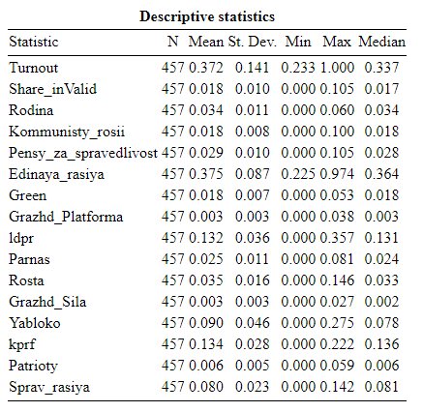

**Block 3**

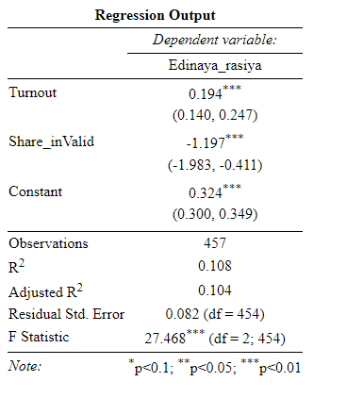

*1. Are there any statistically significant independent variables in the regression?*

There are two statistically significant independent variables in the regression: Turnout and Invalid Share

*2. What is the direction of relationship between each of the independent variables and dependent*

*variable?*

Between Edinaya_rasiya and Turnout there is a positive direction of relationship

Between Edinaya_rasiya and Share_inValid there is a negative direction of relationship

*3. What is the predictive capability of the model?*

“Multiple R-squared: 0.1079, Adjusted R-squared: 0.104” so the share of variability of the model is about 10,4%-10,8%

*4. What does F-statistic say about the model’s characteristics?*

p-value: 5.483e-12 < 0.05 so the model has predictive capability

**Block 4**

1. Multicollinearity



*Brief interpretation*: nothing is greater than 10 so there is no multicollinearity

2. Heteroscedasticity

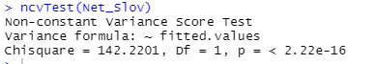

*Brief interpretation: TEST:* p = < 2.22e-16 (<0.05) so the problem exists and it hinders the model’s characteristics | PLOT: the blue dashed trendline going up and pink reference line varying SO there is might be a problem of heteroscedasticity

Visualization:

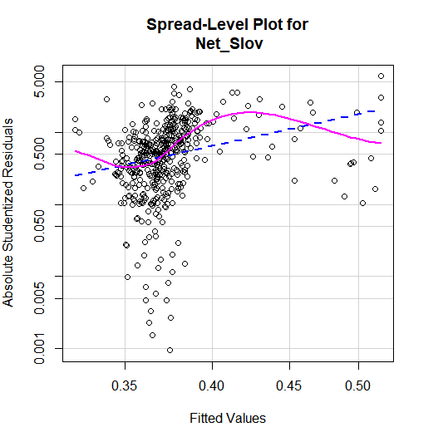

3. Outliers

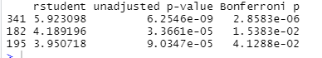

*Brief interpretation*: outliers are in the lines 341, 182, 195 because their *Bonferroni p -value*< 0.05

4. Influential observations

*Brief interpretation*: no influential observations in the graph because none of them is greater than 1

Visualization:

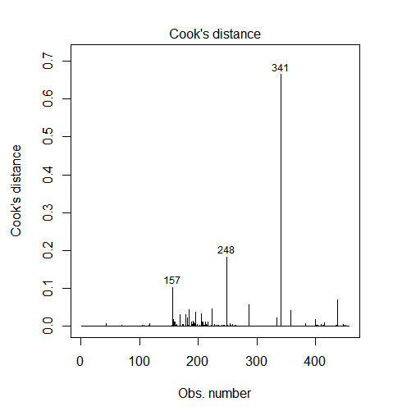

5. Interaction effect

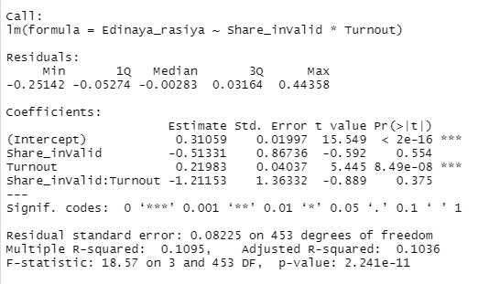

*Brief interpretation:* no interaction effect because p-value for “Share_inValid:Turnout” is 0.375 > 0.05 so we can not reject the hypothesis 0